# **7.1 Introduction**

Testing of the System is critical for the delivery of a successful project. The key purpose of testing is to check whether that the developed system is fulfilled the user requirements and confirms to the test results expected under a wide range of conditions which could have been tested. To accomplish a successful system implementation, all aspects of the testing segment should be reviewed with the contribution of the developer as well as users. In this chapter it is illustrated about the types of testing used for developed software product and test plans for used in the process. As the last main topic in this chapter it is discussed about the implementation plan, which includes the factors need to be considered when system is implemented in the real environment.

# **7.2 System Testing Objectives**

System testing enables the developed solution to be analyzed entirely in order to ensure that the specifications and business functions which it was intended are being met. The components of the system are being tested at the development of those components. But it is necessary to test those components to confirm the combinations of the system components were properly done.

System testing is conducted by checking the fallowing checkpoints are tailored with the developed system.

* Performance –This testing is performed to verify the system operate under peak and continuous loads of processes at a significant speed.
* Accuracy – Inaccurate information leads the whole system failure if the information is not stable. The test is performed to verify the outputs of the system are accurate in various operational environments.
* Functionality – Test is performed to make sure the system meet requirement specifications and hence supports business requirements of the company. Functionalities should address the problems existed in current system and its processes.
* Interfaces – New solution components are developed to provide more information using less number of interfaces and users should be able identify them easily and separately. Testing is performed to make sure the interfaces are done according to the specifications and the interfaces are linked each other in well-organized manner.
* Security – Since the system handles sensitive information of the organization’s and it’s users security of the system should be well-ensured, this testing is performed to verify the feature of the system ensure access, integrity and recovery features operate as expected.

# **7.3 Testing Strategy**

A proper testing strategy is needed for the finishing of a good product. The developers intend to give the best finished product to the buyers. Testing is done in different methods and such methods are elaborated below. It is important that the testing is done in a step by step basis and that the different types of tests are related to each other.

# **7.3.1 Unit testing**

Unit testing which also known as module is testing is a kind of procedure used to verify that each unit of source code is functioning correctly. In an application, the smallest testable part is the unit. Units of a system are differentiated from modules and those modules are made up of units. Unit testing will only test the components of the system and it will not help to recognize every fault in that system such as integration errors, performance errors and any system related issues. Unit testing will only be effective when it used along with other testing techniques. Typically this testing is done only by the system developers and not by the users who are going to use the system finally at the real operational environment. This was conducted while developing the solution. Each written piece of code is tested for errors.

# **7.3.2 Integration testing**

Integration testing which is also known as Integration and Testing is a kind of testing in which the individual modules in the software are combined and tested those as a cluster. Purpose of conducting the integration testing is verifying the functional and performance requirements defined on project design specifications. Integration testing takes as its input modules that have been unit tested, groups them in larger aggregates, applies tests defined in an integration test plan to those aggregates, and delivers as its output the integrated system ready for system testing. There can be many types of integration testing such as back bone, bottom-up, top-down and big bang. Integration tests can not include system-wide change testing.

# **7.3.3 System Testing**

Overall functionalities of the system including the modules integrated modules and interfaces will be tested out of the system testing. System testing will not receive many errors since the input which is taken to the system testing is the system and modules which are tested under unit testing and integration testing. But the errors which identify during this testing process will be critical since it will be affected to the integration of the solutions various modules with each other and leads to changes of the system as a whole.

# **7.3.4 Acceptance Testing**

Acceptance testing is a black-box testing which will be the next to be conducted. It is designed to ensure that all the changes made come across with the original system specifications and user requirements of the solution during the design, development and other initial stages. Basically this will decide the how the extend solution has completed the user requirements. Acceptance phase may also act as the final quality gateway, where any quality defects not previously detected may be uncovered

# **7.4 Test Plan**

Test plan defines a systematic approach to test a system. This will discuss the process of conducting the above mentioned testing strategies. Under test plan, test strategies which are identified as to be carried, will be separated into to testing plans as unit testing and system testing. Components of the system and integration of components will be carried under unit testing. System testing and acceptance testing will be carried under System testing. Concerns made when designing the test plan are,

* Identifying the components and features to be tested and not tested
* Ensuring all required elements are in place for testing
* Who conducts the testing for particular component or feature
* Plan for make necessary changes for issues arise on testing

Below table illustrate the system test plan for web application

|  |  |
| --- | --- |
| Test Scenario | Description |
| Test and validate login module for web application | Check whether the login interface is aligned with the user experience guides, results when the credentials are correct and wrong, session control and the logout function from the system. |
| Test and validate the functions of policy module | Check whether the policy module is loading properly. Check whether it is possible add a new policy for a client filling out the necessary details. Once it is submitted record should be visible in the data grid. Grant the permission to do necessary modifications to certain details of a policy. |
| Test and validate the claim request handling module | Check whether the requests sent by the clients are received by the systems in a quick manner. And view the request and respond to the request and change the state of the request. |
| Test and validate the functions of reviewing and approving the claim | Check whether manager is being able to view the claim report submitted by the claim agent and review it and approve it for money transfer. |
| Test and validate the functions of garage services module. | Check whether existing data are retrieved from database and displayed on the data grid. Check whether the searching is working providing indicated parameters. Check the ability to add, edit or delete data from/to database. |
| Test and validate the functions of tow truck services module. | Check whether existing data are retrieved from database and displayed on the data grid. Check whether the searching is working providing indicated parameters. Check the ability to add, edit or delete data from/to database. |
| Test and validate the functions of vehicle templates module. | Check whether existing data are retrieved from database and displayed on the data grid. Check whether the searching is working providing indicated parameters. Check the ability to add, edit or delete data from/to database. |
| Test and validate the functions of spare parts module. | Check whether existing data are retrieved from database and displayed on the data grid. Check whether the searching is working providing indicated parameters. Check the ability to add, edit or delete data from/to database. |
| Test and validate the functions of manufacturers’ module. | Check whether existing data are retrieved from database and displayed on the data grid. Check whether the searching is working providing indicated parameters. Check the ability to add, edit or delete data from/to database. |
| Test and validate the functions of spare categories module. | Check whether existing data are retrieved from database and displayed on the data grid. Check whether the searching is working providing indicated parameters. Check the ability to add, edit or delete data from/to database. |
| Test and validate the functions of employees and user accounts modules. | Check whether existing data are retrieved from database and displayed on the data grid. Check whether the searching is working providing indicated parameters. Check the ability to add, edit or delete data from/to database. |

Table 1: System Test Plan-Web Application

Below table illustrate the system test plan for tab application

|  |  |
| --- | --- |
| Test Scenario | Description |
| Test and validate login module for tab application | Check whether the login interface is aligned with the user experience guides, results when the credentials are correct and wrong, and the logout function from the system. |
| Testing and validating Policy information module. | Test whether the system identifies the customer’s policy number and allows the agent to retrieve the relevant data of the relevant module from the company database through the web service. |
| Test and validate the claim form filling procedure | Make sure that only after giving the policy number agent can go to this screen. All the required fields must be checked before submitting the response. Finally agent must be able to submit the data and get the success message. |
| Testing and validating Vehicle component information module. | Test whether the system chooses the particular parts list after the part category is selected from the pick list, and whether the right price is given, of the damaged spare part chosen. Test whether the system can add /remove the damaged spare parts to claim and whether it displays on screen. When each item is added, the value and details of the item should be shown in a table. |
| Test and validate garage services module in tab application | Check whether the data are retrieved through the web service and also check whether filtering works. |
| Test and validate tow truck services module in tab application | Check whether the data are retrieved through the web service and also check whether filtering works. |

Table 2: System Test Plan-Tab Application

Below table illustrate the system test plan for WCF service.

|  |  |
| --- | --- |
| Test Scenario | Description |
| Test and validate the WCF service hosted by looking in to exposed methods | Check whether all the necessary methods are exposed and check in the WCF test client whether they all response with correct set of data. |

Table 3: WCF Service Test Plan

Below table illustrate the system test plan for web application

|  |  |
| --- | --- |
| Test Scenario | Description |
| Test and validate the smartphone applications report accident for claiming. | Run the smartphone application and check whether the report function is working. Check with various policy number inputs. |

Table 4: System Test Plan-Mobile Application

# **7.5 Test Results**

Test logs

Test Case: Testing and validating login function

Description: Test the user login for the valid user name and password. The user login should identify the user’s privileges, id and the user’s name. Only the authenticated users who are registered to use the tab application system should be allowed to login.

Test Data: 1. Try to login without credentials

**Expected Output**

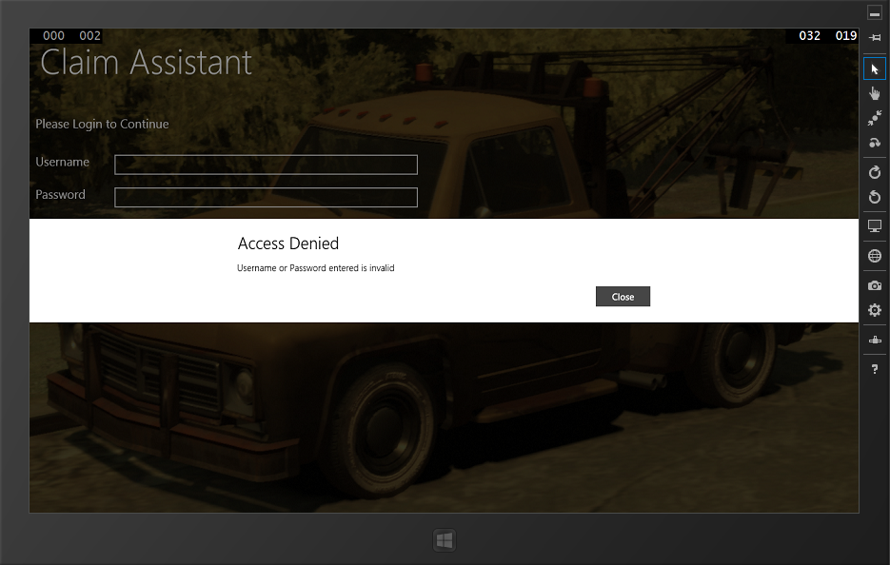

**Test Result**: Successfully received the expected message

2. Try to login with invalid credentials

**Expected Output**

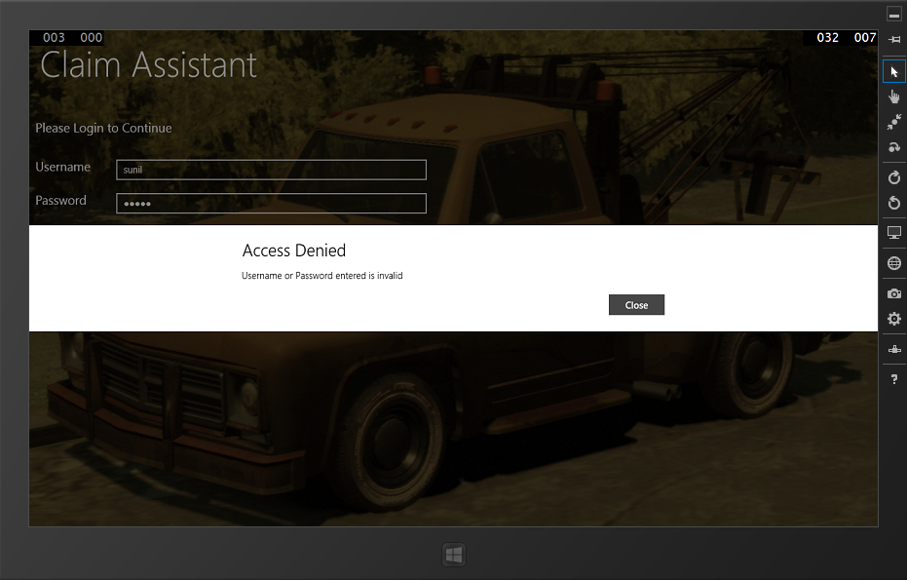

**Test Result**: Successfully received the expected message

3. Try to login when network unavailable

**Expected Output**

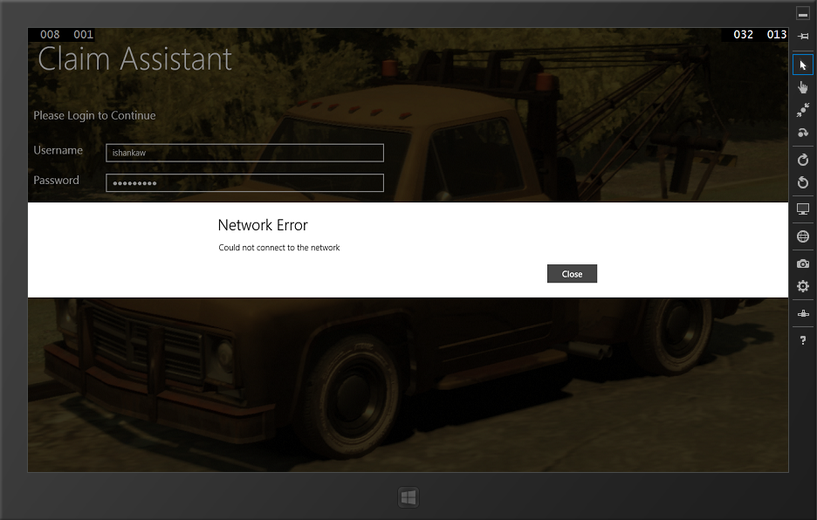

**Test Result**: Successfully received the expected message

3. Try to login when without enough access.

**Expected Output**

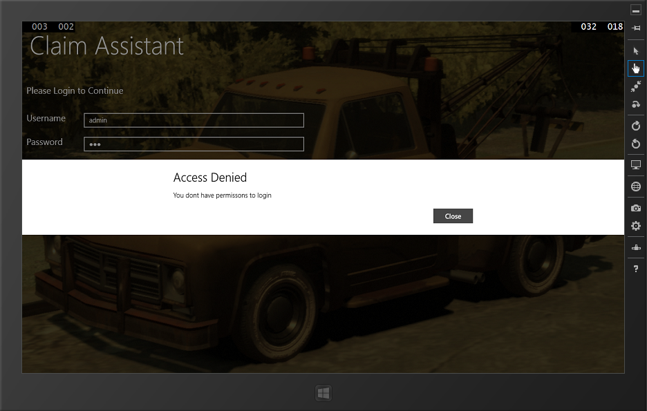

**Test Result**: Successfully received the expected message

4. Try to login with valid credentials

**Expected Output**

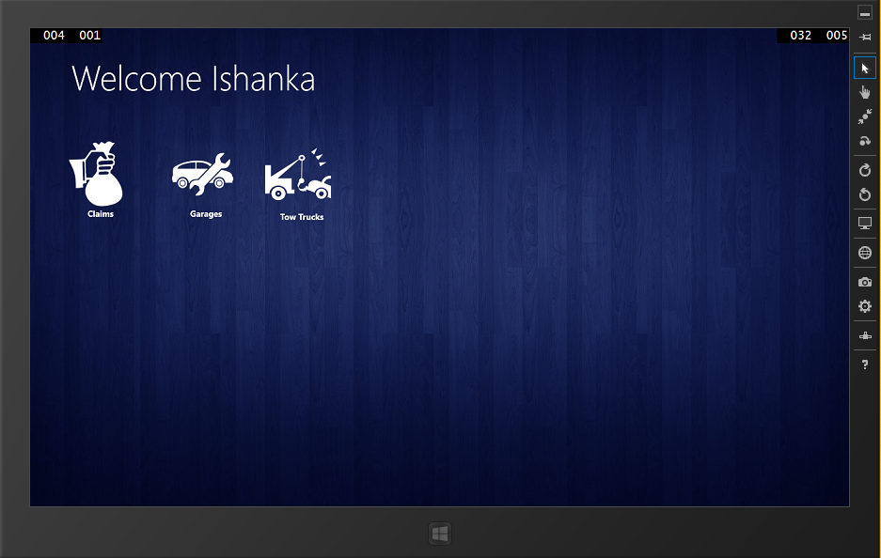

**Test Result**: Successfully received the expected output. User logged in successfully. Next screen displayed.

Test logs

Test Case: Testing and validating Policy information module.

Description: Test whether the system identifies the customer’s policy numbers and allows the agent to retrieve the relevant data of the relevant module from the company database through the web service.

Test Data:

1. Submit without policy number

**Expected Output**

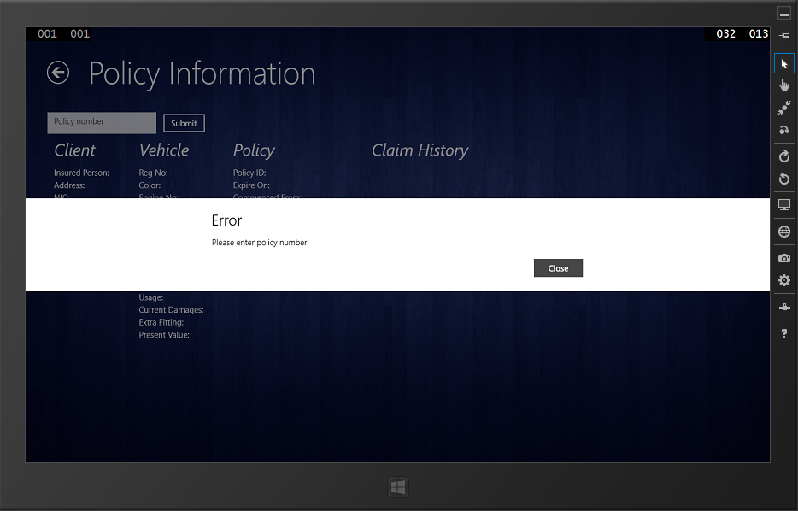

**Test Result**: Successfully received the expected message

2. Submit with invalid policy number

**Expected Output**

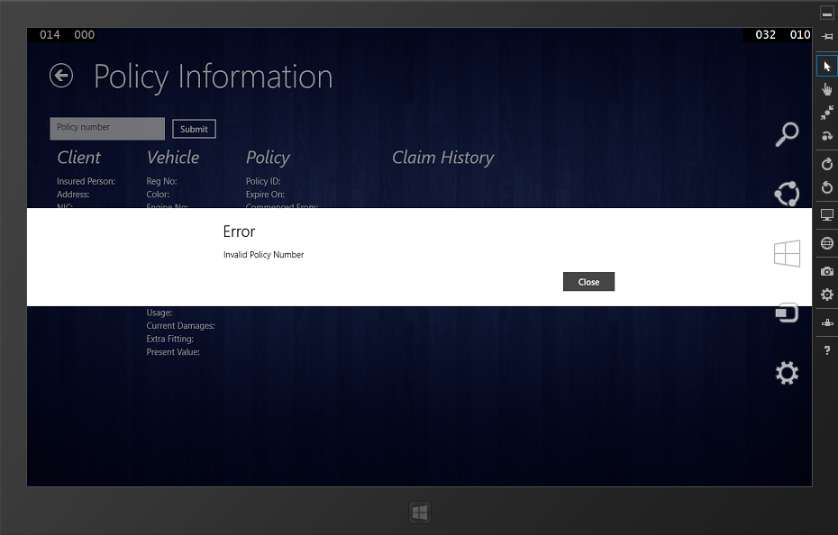

**Test Result**: Successfully received the expected message

3. Submit with valid policy number

**Expected Output**

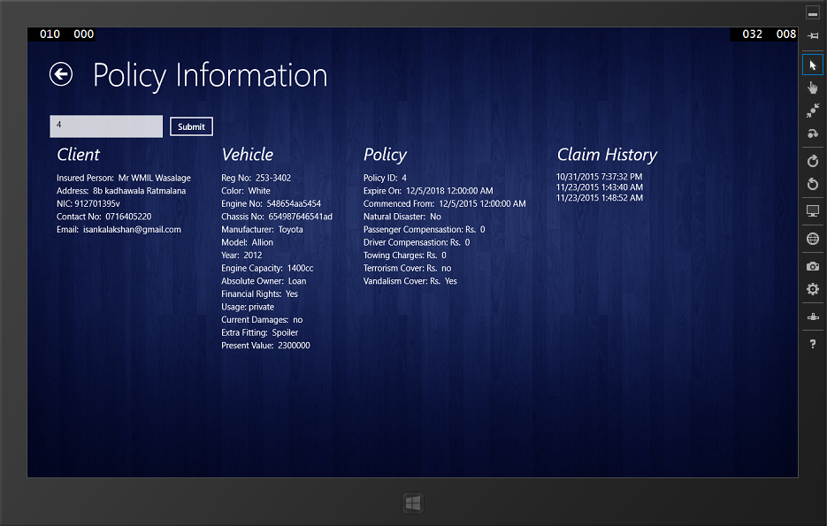

**Test Result**: Successfully received the expected information

Test logs

Test Case: Testing and validating claim assessing

Description: Test whether policy number has being entered before moving to the claim form filling. Then check whether all the required fields are entered. If entered can move to the next screen and finally submit.

Test Data:

1. When agent tries to claim without entering clients policy number

**Expected Output**

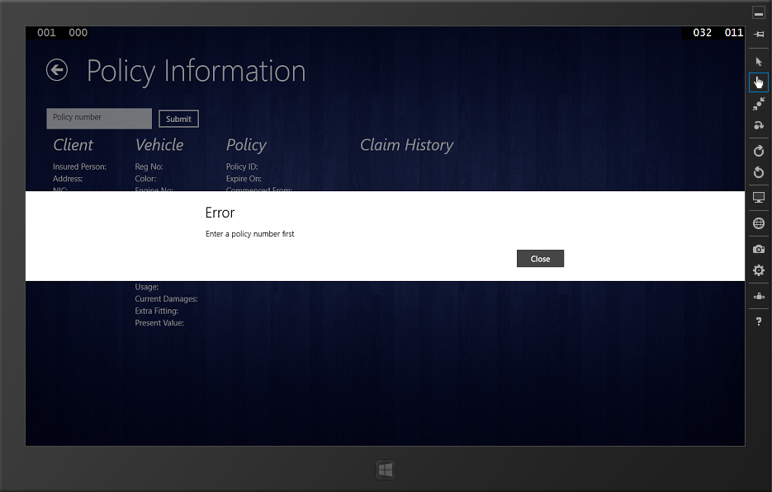

**Test Result**: Successfully received the expected message

1. When user enter policy number then press claim button.

**Expected Output**

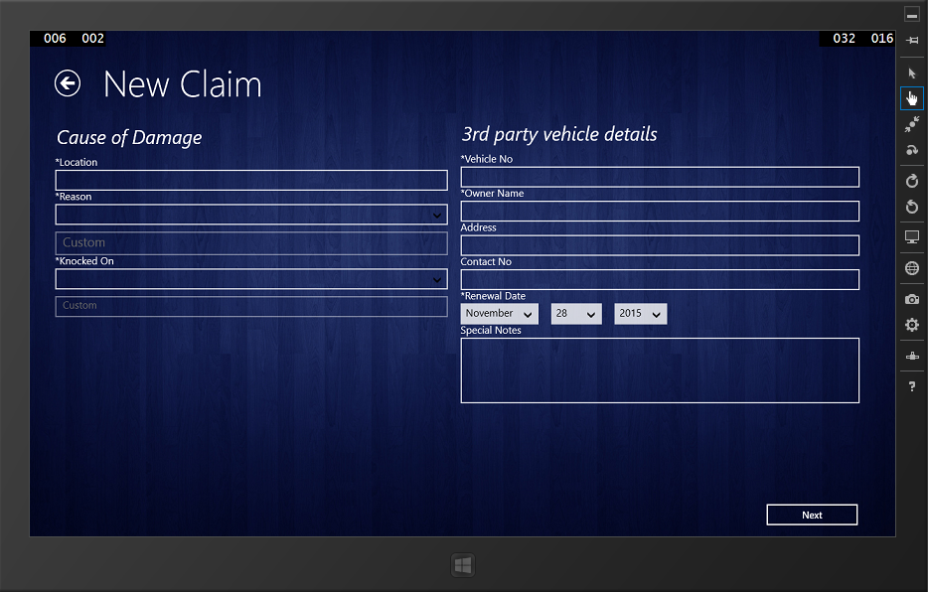

**Test Result**: Successfully received the expected message

1. Checking for required filed in claim form

**Expected Output**

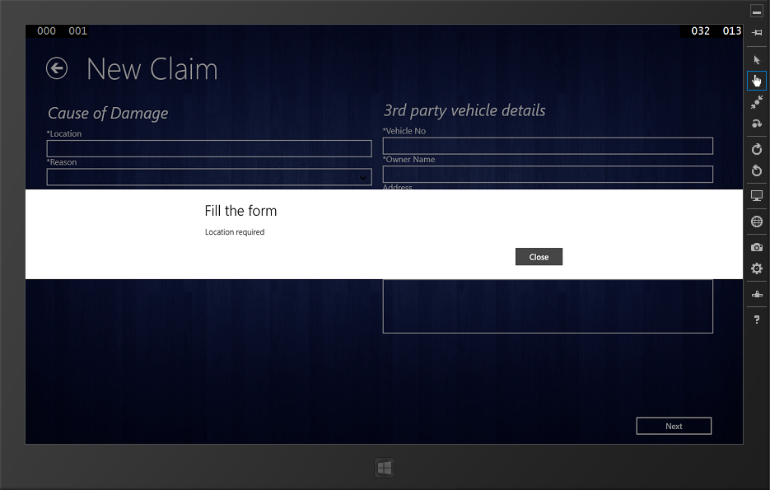

**Test Result**: Successfully received the expected message

1. On successful completion of filling first form and press Next button

**Expected Output**

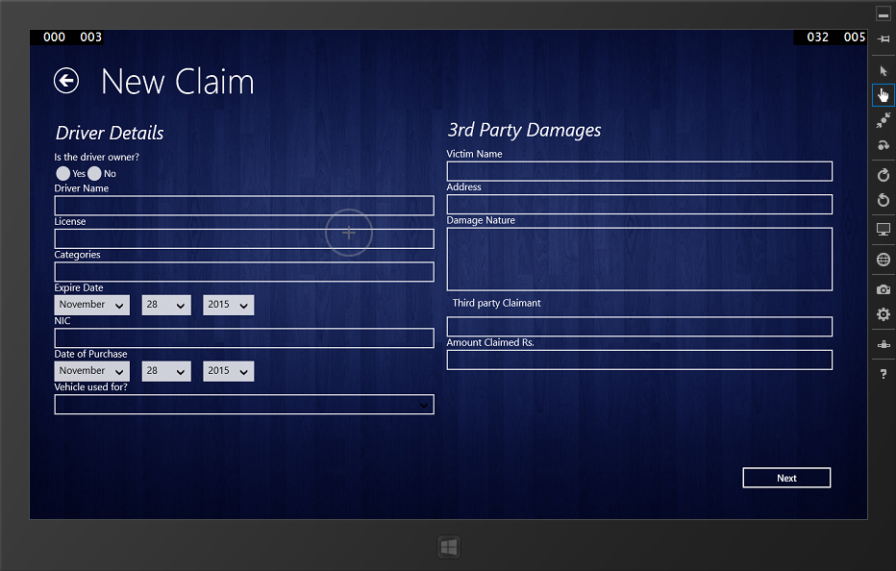

**Test Result**: Successfully received the expected message

1. On successful completion of filling second form and press Next button

**Expected Output**

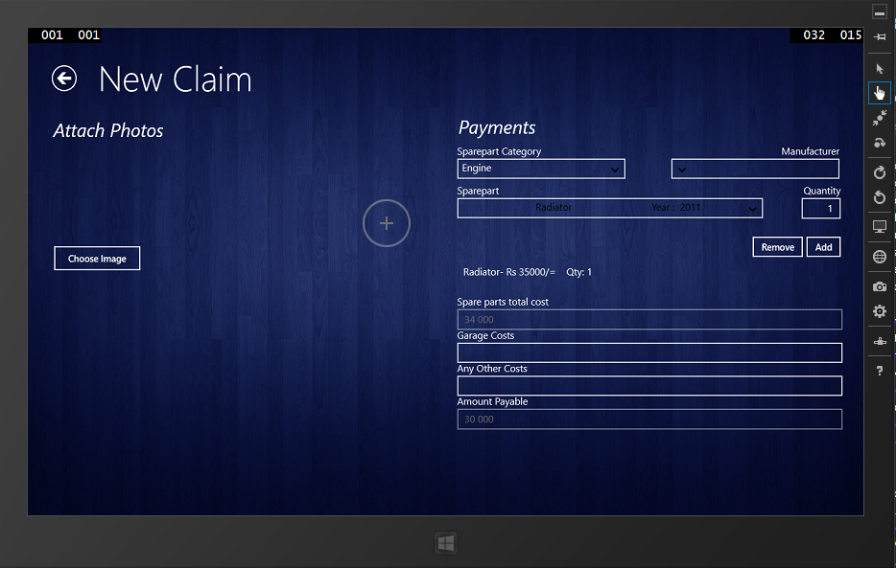

**Test Result**: Successfully received the expected message

1. On successful submit of claim

**Expected Output**

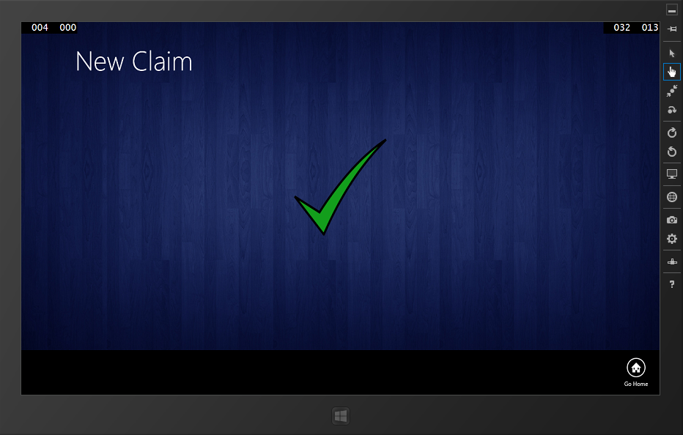

**Test Result**: Successfully received the expected message

**Test logs**

**Test Case:** Testing and validating vehicle spare part informationmodule.

**Description:** Test whether application retrieves spare part information from the company database and the system can add /remove the damaged spare part/parts and weather it displays on screen. When each item is added, the value and details of the item should be shown in a table.

**Test data:**

1. Check whether data are retrieved

**Expected Output**

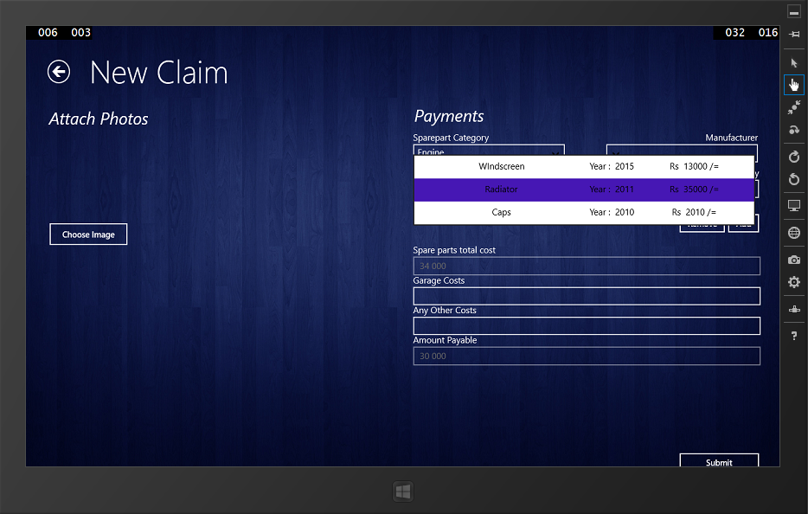

**Test Result**: Successfully received the expected output.

1. Check whether an item can be added to the claim

**Expected Output**



**Test Result**: Successfully received the expected output.

**Test logs**

**Test Case:** Testing and validating vehicle spare part informationmodule.

**Description:** Test whether application retrieves garage and tow truck services information from the company database. And also checking whether searching items by location function properly.

1. Get all garages services information

**Expected Output**

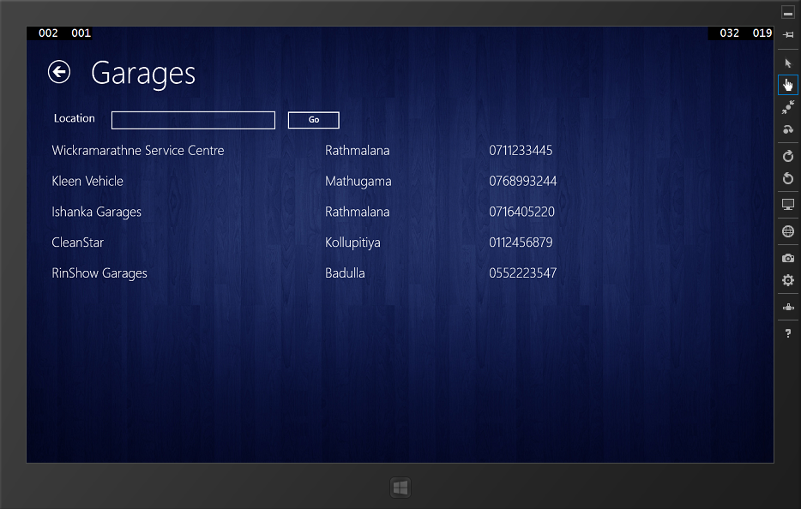

**Test Result**: Successfully received the expected output.

1. Get all tow truck services information

**Expected Output**

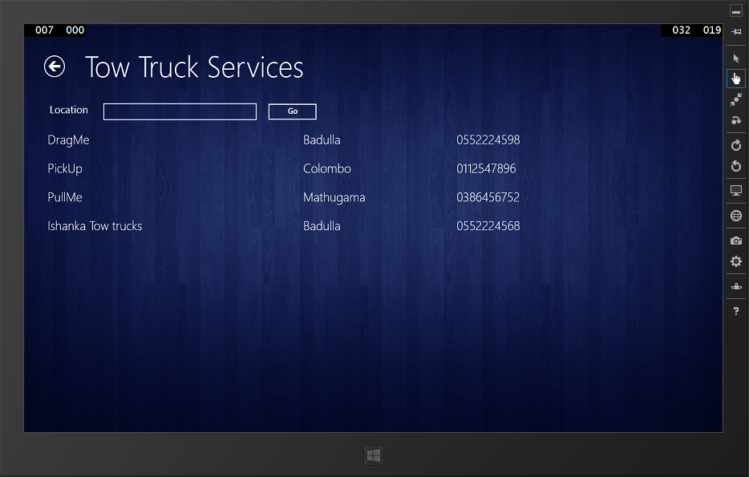

**Test Result**: Successfully received the expected output.

1. Search by location in garages services

**Expected Output**

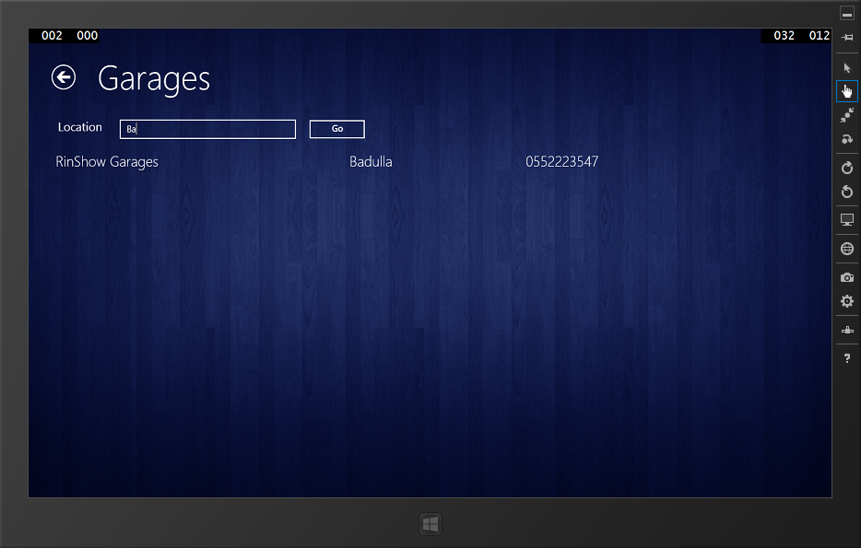

**Test Result**: Successfully received the expected output.

1. Search by location in truck services

**Expected Output**

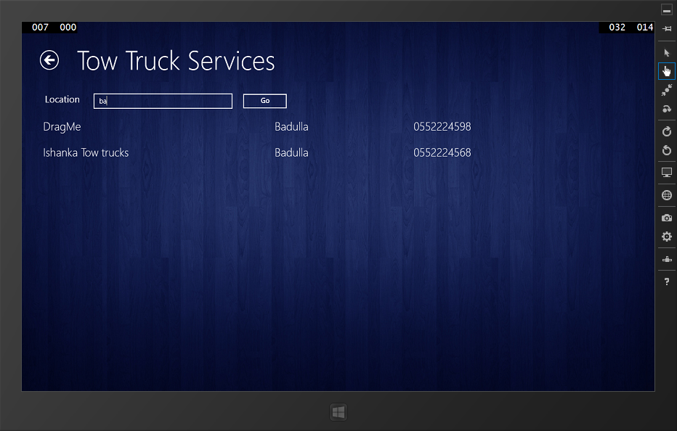

**Test Result**: Successfully received the expected output.

**Test logs**

**Test Case:** Testing and validating smartphone application.

**Description:** Test and validate claim request reporting module.

1. Testing when the client submits without policy number

**Expected Output**

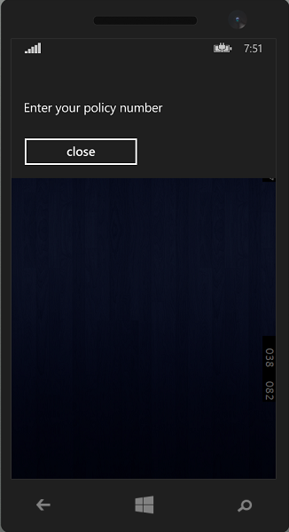

**Test Result**: Successfully received the expected output.

1. Testing when the client submits with invalid policy number

**Expected Output**

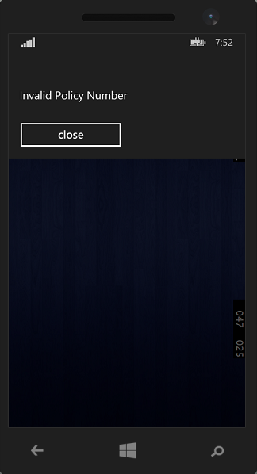

**Test Result**: Successfully received the expected output.

1. Testing when the client submits with valid policy number

**Expected Output**

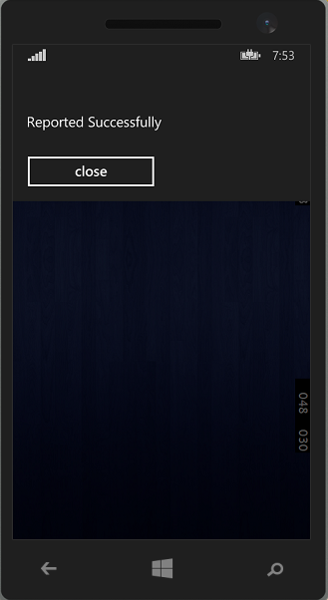

**Test Result**: Successfully received the expected output.

# **7.6 Implementation Plan**

The importance of having a good implementation plan is that the prepared system can be introduced to the client step by step. It would minimize the wastage of time and also money. A proper plan should be adhered by both the developers and the insurance company. The main activities of the implementation plan is to give a system overview, key activities on system implementation and any other vital requirements that helps to the process of implementation.

# **7.7 System overview**

Implementation of the TBMVCS would idyllically observe the departure of the old procedure of performing the claiming process manually. Therefore it is necessary to provide a smooth transition, when changing from manual to the computerized system. And as a result of this transition, users may find difficult to cope up with the new functions of the new system. So it is very essential to provide support for the user in order to handle the new functionalities of the new system.

The TBMVCS would make the Motor vehicle insurance claiming more transparent and efficient both for the employers of the company the clients who pay monthly insurance premiums. Not only this but the claiming agents would be motivated a lot since their work is cut down in half and they are able to cover more vehicle claims during a day. This would result in quicker response, better payment and more concern for customer satisfaction. The basis is to switch to smart devices technology from the use of manual handwritten filing methods.

# **7.8 Major Tasks on System Implementation**

• Planning overall implementation

• Co-ordination of the system implementation with the management of the company

• Testing the Tab application and Mobile application along with the data connections

• Identifying resource requirements for the implementation

• Finding a source to get market prices for vehicle spare parts

• Providing training for the claiming agents

• Planning data conversion methods before implementing the system

• Planning a risk management system

• Ensure all the required hardware and software is available

# **7.9 Installation**

According to the implementation plan the first activity that should be done by us is to install the system at the real operational environment. Implementation of the TBMVCS should be done with the help and the guidance of the management of the Insurance Company. Since the solution is developed commonly for insurance companies we may need to do small changes to the user interface such as adding their logo. Successfully developed and tested TBMVCS should be set up in order to reduce the perils and contingency which expressed in the above section. Procedure of the system installation is given below.

* If hosted in a separate server the operating system on server (SQL server 2012 above preferred) should be installed first. Another easier option will be hosting on Azure which is Microsoft cloud platform
* Microsoft SQL should be installed in order to support the database connectivity. Azure comes with SQL server as well.
* Connect the code repository to the website created enabling continuous integration for updating the system
* After that we have to restore the database
* Make essential configurations for the BMVCS
* Install the Tab application on company devices.

Detailed installation, Hardware and software configuration and user manual procedure is attached in APPENDIX I

# **7.10 System Changeover**

The direct changeover method will not be followed but parallel changeover will be carried on TBMVCS system because the company would not be able to take the change so soon. The reason is that there are so many existing customers and claiming staff members who are used to the old system. Also since the management would want to find the bugs in the process of the implementation, the parallel changeover would be the better deal. This will reduce the risk of business and give the new users time to adjust to the new system. Since the 3 component are dependent on each other all components are implemented in the business process. Mobile application can be directly used since it does not have a direct impact on the company business process but a value addition.

# **7. 11 Data Conversion**

The practical solution is to start the data conversion after the implementation of the system. The current claim data can be taken from the Insurance Company’s database. Some of the data has to be entered fresh since the TBMVCS system intends the new features. Also the parallel method used can take the data entering from fresh new customers of the insurance company. Data conversion for the online assessment system should be entered manually and will take some time since it has to find the prices of the vehicle spare parts. It is appropriate to mention that some of the data would be fed on a time ticking basis since the prices of vehicle spare parts could appreciate and depreciate in the market.

# **7. 12 User Training**

Most of thepresent claiming staff are quite proficient with computers and other smart devices. In the modern world most people are familiar with the use of smart mobile phones. Since the TBMVCS system, tab application and smart phone application has a very simple user friendly interface they need not be trained much on this. Since there is no big difference in the functionality of the system and the difference is more of a convenience the motivation of the staff members would be at a high. It is necessary to inform the entire user about the functionality of the system during this implementation. There would be no need for new rules and regulations except for the safety of the devices when travelling with them. The data operators at the Head Office would have to be a very minimal staff and could also act as the monitors of the insurance claims being done around the island.

# **7.13 Summary**

The system testing that occur along with the system development and the activities that occur before the delivery of the product called implementation were expressed. In agile approach testing is concurrently conducted with the development and the testing has done in several test runs to determine all the defects. Manual testing methodologies were used since the time was not enough for dig deep into adopt to test automation methodologies. Implementation plan has the sequence order of set of activities such as installation, data conversion, and change over and user training.